Changes to Blockshelf Wiring
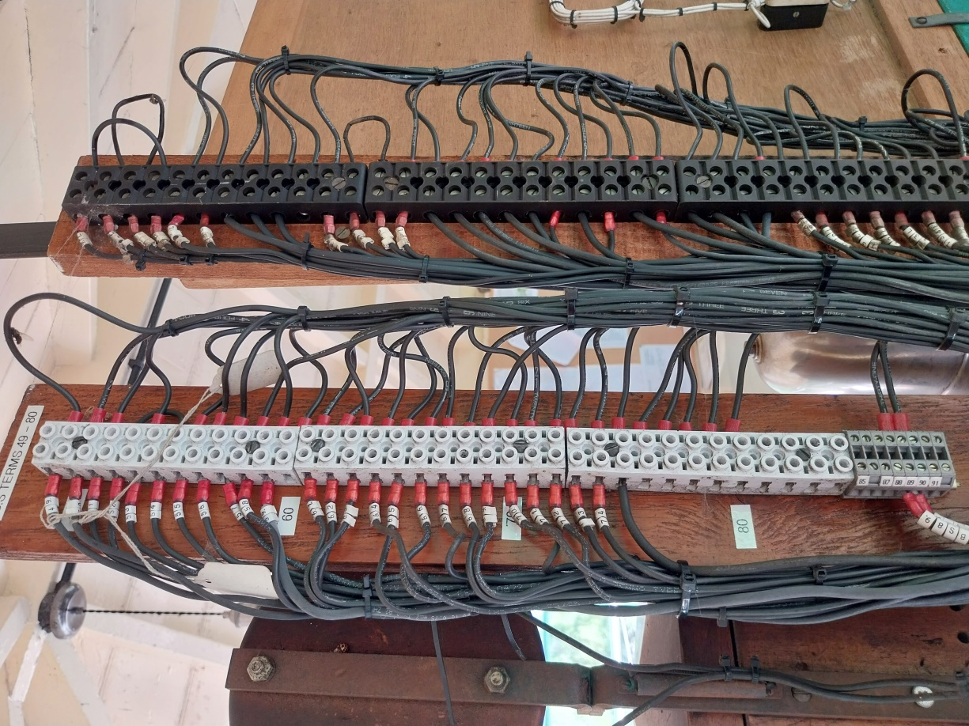
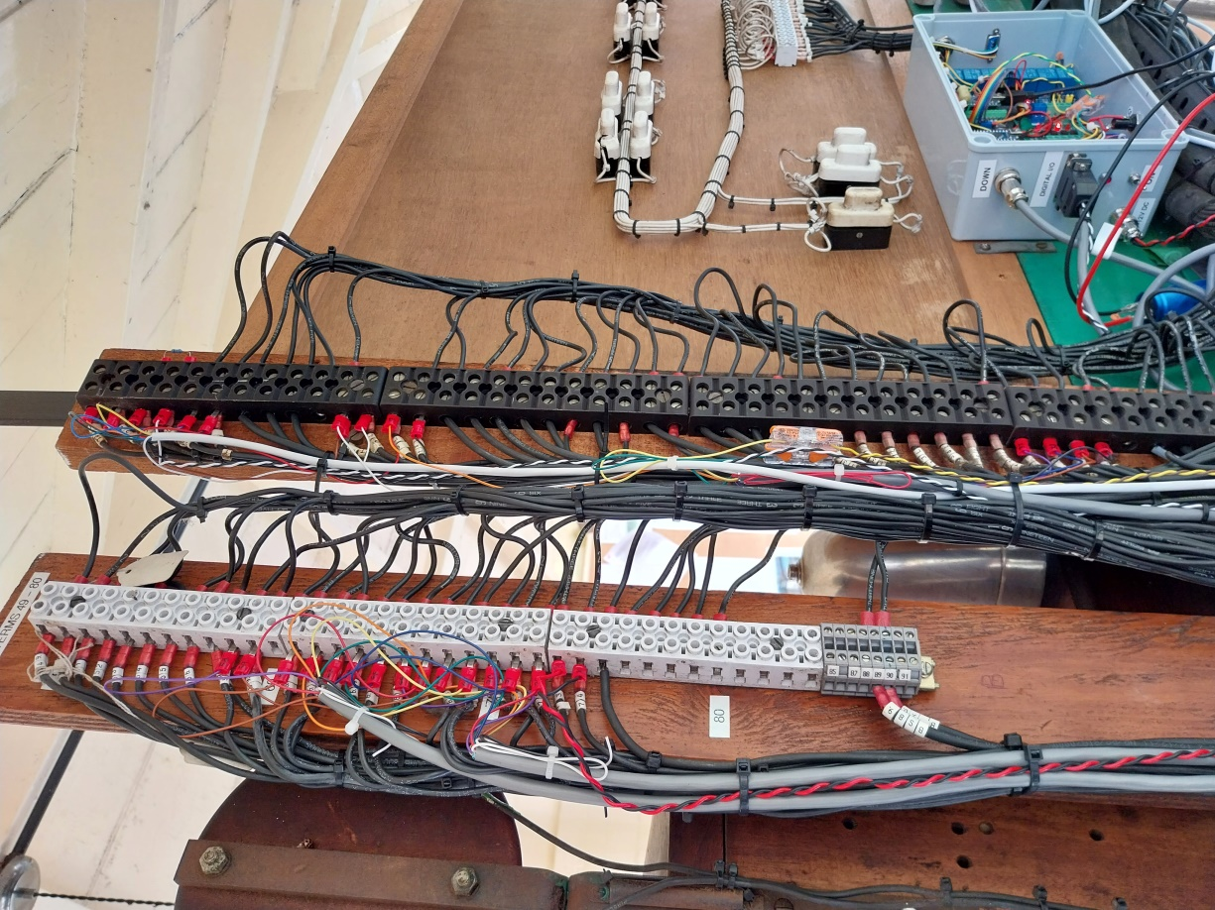
1000ohm resistor
Original Links:
1 to 4 and 2 to 3
New Wiring
Original Wiring
New cables

